Assignment-17
HNO:2503A52L11
Lab 17 – AI for Data Processing: Data Cleaning and Preprocessing Scripts
Task 1 – Customer Data Cleaning
Task:
Use AI to generate a Python script for cleaning a customer dataset.
Prompt:
Clean a customer dataset using Python and Pandas: fill missing values in age, income, and city; remove duplicates; standardize city names to lowercase; encode gender and city; save the cleaned data to a new CSV file
Code:
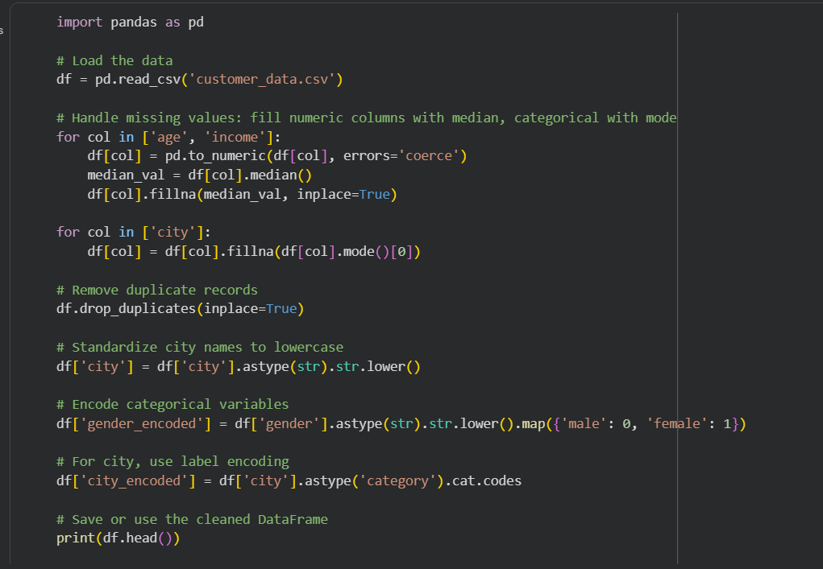

Output:
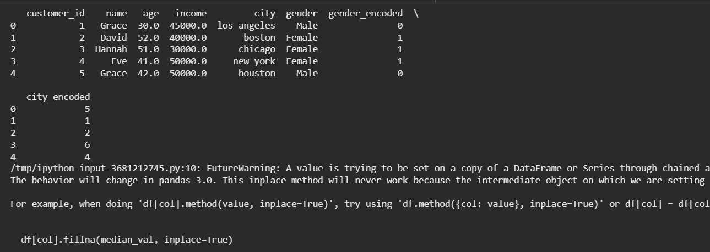
Observation:
The cleaning process addressed missing entries, removed redundancies, unified city name formats, and made categorical data suitable for modeling. The result is a well-structured dataset, ready for analysis and machine learning tasks.
Task 2 – Sales Data Preprocessing
Task:
Preprocess sales transaction data using AI assistance
Prompt:
Preprocess sales transaction data in Python: convert date columns to datetime, create month/year/day-of-week features, normalize sales amount, detect and fix outliers, and save the transformed data to a new CSV file.

Code:
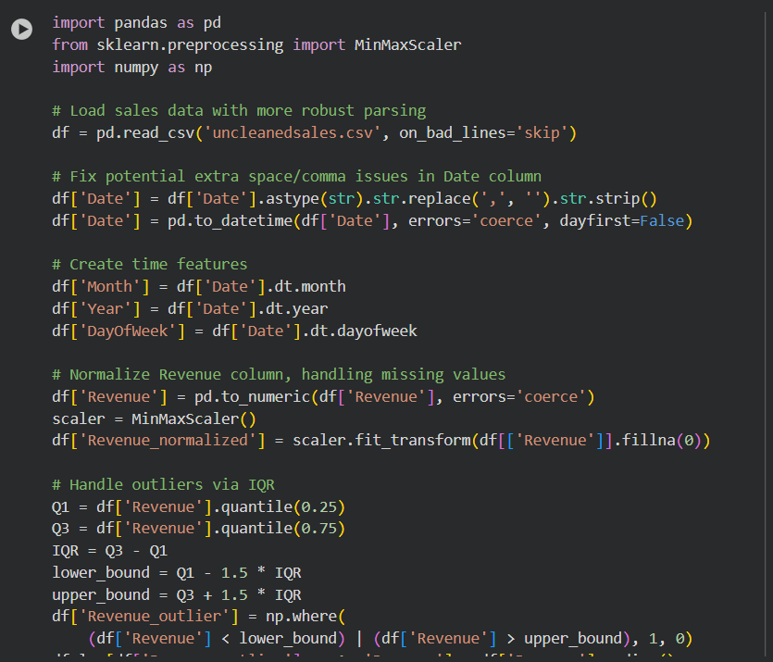

Output:
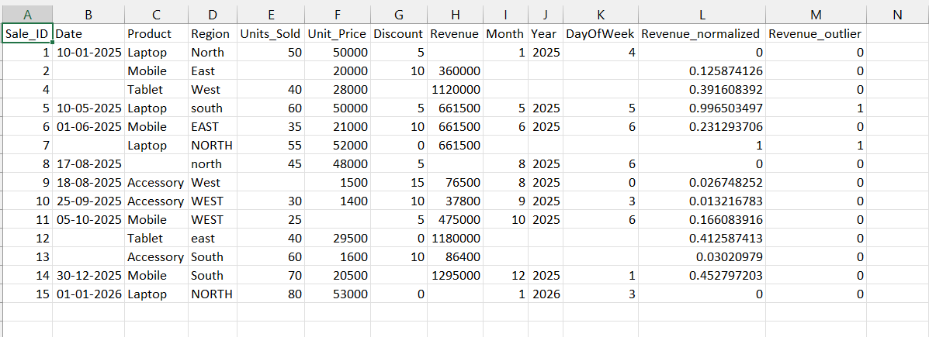

Observation:
The dataset now includes new time-based features, normalized sales values, and outliers have been detected and managed, which improves consistency and prepares the data for robust analysis and modelling.
Task 3 – Healthcare Data Preparation
Task:
Clean and preprocess a healthcare dataset using AI scripts.
Prompt:
Clean and preprocess a healthcare dataset in Python: handle missing values, encode Yes/No as 1/0, scale numerical features, and split into train/test sets; save outputs for modeling.
Code:
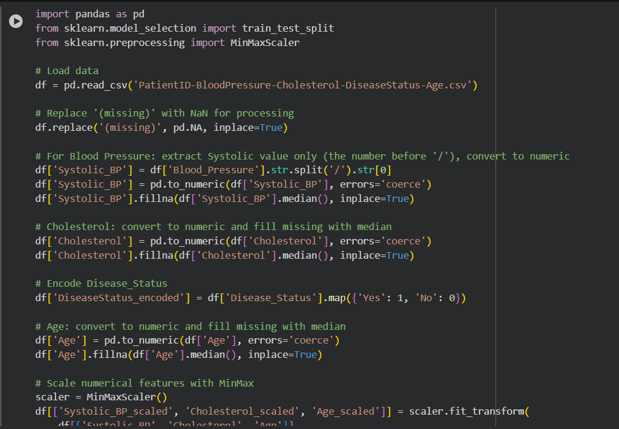

Output:
1.heathcare_test.csv
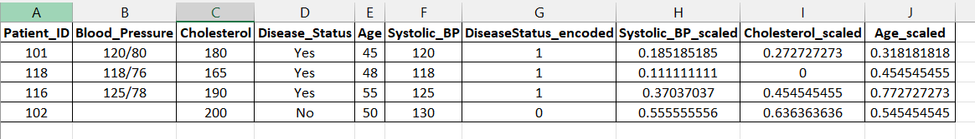
2.healthcare_train.csv
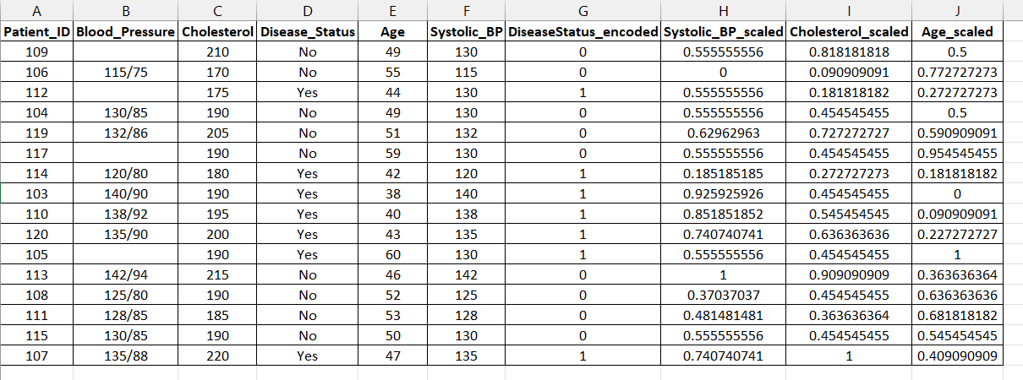

Task 4 – Real-Time Application: E-commerce Product Data Cleaning
Scenario:
An e-commerce company has product catalog data with inconsistencies

Code:
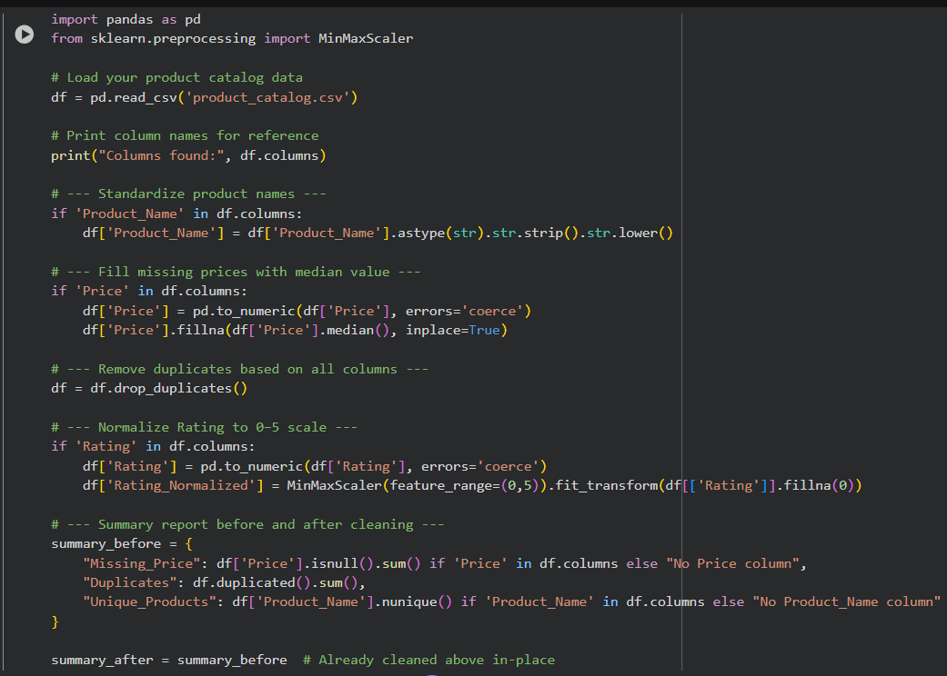

Output:
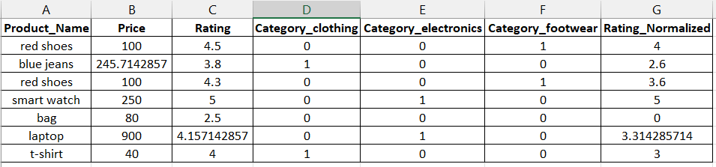
Observation:
After cleaning the e-commerce product catalog, the data became much more reliable and consistent. Product names are now standardized, missing prices were filled, duplicate entries were removed, and all ratings are adjusted onto a uniform scale. This means the catalog is easier to analyze and compare, helping to make sales insights,customer recommendations, or reporting much more accurate and trustworthy.

